# Create Health Canada DPD in MySQL

1. Ensure you have phpMyAdmin installed on the Web Server
2. Import the table script in phpMyAdmin

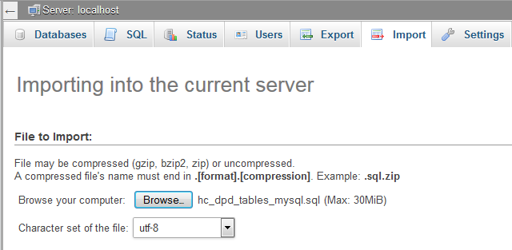

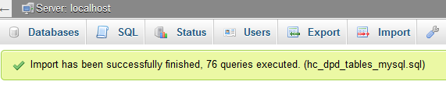

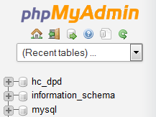

1. Open an SSH terminal to your Server
2. Get the DPD files (extracts)

**wget http://www.hc-sc.gc.ca/dhp-mps/alt_formats/zip/prodpharma/databasdon/allfiles.zip**

1. Unzip the files (may need to install unzip)
2. Copy the extracted files to **/var/lib/mysql/hc_dpd/**
3. in your SSH connection execute this: mysql -h localhost -u <MySQL Username> -p<password>

*** yes, the -p and password must be together with no space between them

1. Be sure to select the hc_dpd database before executing the scripts!
2. Then execute the MySQL Import Strings (each separately)

Found in the MySQL Import Strings.txt file

